**z**

**BOUTIQUE SHOP MANAGEMENT SYSTEM**

**SYSTEM DOCUMENTATION**

**SUBMITTED BY,**

**MWAMRIZI TIMOTHY KARINGO**

**DSE-01-1341/2021**

**A SYSTEM DOCUMENTATION SUBMITTED IN PARTIAL FULFILMENT FOR THE AWARD OF DIPLOMA IN *MY COURSE* BY ZETECH UNIVERSITY**

**APRIL, 2023**

DECLARATION

I Mwamrizi Timothy Karingo declare that this proposal is my original work and has not been presented to the award of a diploma in any university or any other award.

SIGNATURE: DATE:

NAME : Mwamrizi Timothy Karingo

REG NO : DSE- 01-1341/2021

SUPERVISOR’S

I confirm that the work reported in this proposal will be carried out by the candidate under my supervision and has been submitted with my approval as the university supervisor.

SIGNATURE:

DR. DATE:

Department of ICT and engineering

# **ACKNOWLEDGEMENT**

I am most grateful to God as this has been a task but I did it.

To my supervisor, I would like to express my sincere gratitude and appreciation for his continued support, generous academic advice, discussions, suggestions, encouragement and guidance.

To my best friends, thank you for your support and encouragement.

To my parents too may God bless you all.

God bless abundantly

Table of Contents

**ACKNOWLEDGEMENT** 3

**LIST OF FIGURES** iv

**LIST OF TABLES** v

**ABBREVIATIONS AND ACRONYMS** vi

**CHAPTER ONE: SYSTEM OVERVIEW** 1

**1.1 Research objectives……**……………………………………………………………………………………………………….……1

**1.1.2 General objectives…**……………………………………………………………………………………………….…………1

**1.1.3 Specific objectives………………………………………………………………………………………………….……….1**

**1.2 Key modules and key features implemented………………………………………………………………….……….2**

**CHAPTER TWO: HIGH LEVEL DESIGN DOCUMENTATION** 3

**CHAPTER THREE: TECHNICAL DOCUMENTATION** 4

**CHAPTER FOUR: TEST DOCUMENTATION** 5

**CHAPTER FIVE: USER MANUAL DOCUMENTATION** 6

**CHAPTER SIX: CONCLUSION AND RECOMMENDATION** 7

**6.1 Conclusion………………...…………………………………………………………………………7**

**6.2 Recommendation…………………….…………………………………………………………………………………………….7**

**APPENDICES** 8

**REFFERENCE** 9

**ABSTRACT**

A boutique is a shop that deals in fashionable clothing or accessories, while management system is a software web-based application which the organization will manage the interrelated parts of its business in order to achieve its objectives. A management system is a key tool in helping to streamline your business processes and build-in efficiency. Boutique system is a type of e-commerce which takes place between an organization and their customers, providing online selling activities as well as online financial transactions. The system maintains the report of placing orders and delivery details, customer details, branch offices details and working staff details and store to the database. This service is necessary and important to the society, as it has helped solve large number of problems. The modules include placing orders and delivery, delivery, customer details and their respective database. The advantage of this system created it can search for bar codes and search according to attributes, if the item has been purchased. Code let you use that instead of creating unnecessary complications, also allows multiple tenders in one single payment by summing up all product costs thus saving time and other resources.

Boutique system can block all sales if inventory is zero meaning you don’t have to of item already sold. boutique of course offer free delivery and percentage discount this intern benefits its customers.

One of the disadvantages is if it not popular it may be risky and may not offer maximized profit and maybe a waste of resources and time. When one opens a boutique, two achievements must be made and that is profit and being able to manage and put everything in control.

Designing and developing the system also is very crucial. You have to consider things like data requirement, program specification, framework and the DBMS of the system to make sure the final product meets the standards of software development process and your customer preference at large because they are the one who will impact positively or negatively. The system meets system requirement specification where functional and non-functional requirement are fulfilled by the website and test them to make sure each feature works as per the requirement. Finally deploy your system application to the customers knowing very well it has met every standard. After delivering to the users, the task you remaining with is management, updating your software, respond to customers preference and adding new features, also ensuring compliance with the software rules, term of service and other thing because it’s a business laws must be followed. A business must be licensed.

Boutique Management system copies other systems like for example one is famous kilimall. Delivery of the product is when the buyer confirms and buys products from system, without an intermediary service, over the internet. It is a form of e-commerce. This project is an attempt to provide the advantage of online shopping with home delivery to customers of instead of going physically to shop. It provides the facility to buy the clothes from anywhere through the internet. Thus, customer will get the service of delivery.

# **LIST OF FIGURES**

**Figure 1**: Application Architecture**………………………………………3**

**Figure 2:** Database architecture of website**………………………………4**

**Figure 2**: Web Testing**……………………………………………………6**

# **LIST OF TABLES**

**Table 1:** Appendix**………………………………………………………………………8**

# **ABBREVIATIONS AND ACRONYMS**

ADMIN – Administrator

HLD – High level documentation

DBMS – Database management system

HTML – Hypertext markup language

MySQL – Structured query language

PHP – Hypertext Preprocessor

CSS – Cascading style sheet

# **CHAPTER ONE: SYSTEM OVERVIEW**

* 1. **Research Objectives**

**1.1.2 General Objective**

The objective of the project is to make a website to sale the clothes in an existing shop. In order to build such a website complete web support, need to be provided. A complete and efficient website which provide the facility to implement the computerization and coding to come up solution of saving time as well as energy, where customer is reduced the burden of going to the physical shops

**1.1.3 Specific Objectives**

The concept of a website is to allow the customer to shop virtually using the internet and allow the customer to buy the clothes of their choice from the website.

* 1. **Key Modules and Key Features Implemented**

**USER**

**User Login** This feature will be used by user/admin to login into system. A user/admin must login with his username and password to the boutique system after registration. If they are invalid, the user is not allowed enter the system. Username and password will be provided after the user registration is confirmed and password should be hidden from others.

**Register New User** A new user will have to register in the boutique shop management system by providing essential details in order to view the whole system, the admin must accept new user by unblocking him. The system must encrypt user password for security purpose.

**Add To Cart** The user can add the desired garments and clothes as the product into his cart by clicking on the cart option and the product. He can view his cart by clicking on the cart button also remove an item from the cart by clicking remove. After confirming the items in the cart, the user can submit the cart and providing a delivery address. On successful submitting the cart will become empty.

**Search for boutique products** the user can search the desired product, view the description of the boutique. After confirming the items in the search user can select it into the cart.

**ADMIN**

**Manage Users, Boutique System** The administrators can add user, delete user, view user. Can add the shop products, delete, hide or view them.

**Manage Orders** Administrators can view orders, update and delete orders. The system must identify the login of the admin and secure accounts

**Features**

Detailed product description - this includes product details, which explain more about the different items. Product photograph to allow viewing of the product listed, this enables customer to understand the product better and make an informed decision.

Social promotion *–* social media platform like, Gmail, contact info so as the customer can communicate when facing technical issues.

Ready-made-templates *–* this are for designing my websiteespecially if you are not a skilled wed developer the templates help simplifiesthe process of setting up system**.**

Footer navigation – to direct user to my social media platforms

# **CHAPTER TWO: HIGH LEVEL DESIGN DOCUMENTATION**

Boutique system is a form of electronic commerce which allows consumers to directly buy goods or services from a seller over the Internet using a web browser or a mobile app. Consumers find a product of interest by visiting the website of the retailer directly or by searching among alternative vendors using a shopping search engine. Website usually enable customer to use "search" features to find specific models, brands or items. Online customers must have access to the Internet and a valid method of payment in order to complete a transaction, such as a credit card, a debit card, or a service such as PayPal.

The HLD documentation presents the structure of the system, such as the database architecture, application architecture (layers), application flow (Navigation), and technology architecture. The HLD uses non-technical to mildly-technical terms which should be understandable to the administrators of the system.

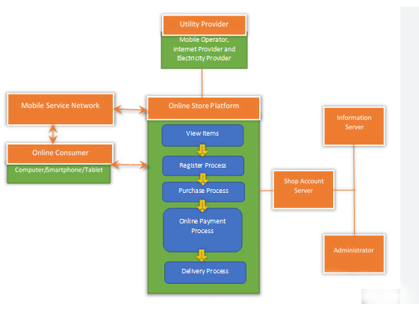

Application architecture

# 

# 

# Database architecture of website

# **CHAPTER THREE: TECHNICAL DOCUMENTATION**

Technical documentation can take many forms, but its main purpose is to explain the features and functionality of product or the system. This includes details on the product roadmaps and plans, software architecture, design process, and intended applications.

As of my system technical product documentation and information that show users how a product should work or how to use a product.

A local web server like XAMMP, WAMP and others

Operating system – Windows, Linux, Mac

Hardware - We strongly recommend a computer fewer than 5 years old.

Processor: Minimum 1 GHz; Recommended 2GHz or more

Hard Drive: Minimum 32 GB; Recommended 64 GB or more

Memory (RAM): Minimum 1 GB; Recommended 4 GB or above

Ethernet connection (LAN) OR a wireless adapter (Wi-Fi) optional

Software which supports recommended browser

The proposed system provides better graphical user interface, Search: Searching details about customer, supplier, employee, Parcel is comparatively easy.

About the system business plan, it’s the products and services will offer which enable the transaction. Boutique will sell a combination of widely recognized name brands as well as clothing lines from select fashion designer. Pricing structure will remain flexible One key feature is providing better services, generation stylish and quality clothing options. As the website grows and the boutique earns a positive reputation, several opportunities will open. And considering some options already. Like develop and grow website by increasing existing clothing lines and expanding our selection, also with more features and modules

My website standards to the user - **Efficiency** When an online dress is bought online and delivered to the home of a customer after he has purchased. This makes the system efficient because no one has to go to the market.

**Reliability -** The boutique management system should provide a reliable environment and ease of use. Also deliver product to the right customer

**Software architecture document**

**Software** architecture design documents, sometimes also called technical specifications, include the main architectural decisions made by the solution architect. Unlike the above-mentioned product requirement document that describes what needs to be built, the architecture design documentation is about how to build it. It has to describe in what way each product component will contribute to and meet the requirements, including solutions, strategies, and methods to achieve that

By building fashion website strategy, the design uses Visual studio and its net frameworks. The trade-off of increased code overhead and message passing is considered justified by the gain of modularization of functionality, data encapsulation, communication through interfaces and re-use through polymorphism. Authentication will be limited to password checking on initial login and a session ID subsequently.

Communication with the users will be by the HTML protocol as this is well-supported by the selected browsers and PHP. PHP and MySQL were selected because they had the necessary capabilities to provide the needed services to the user, the view component is the presentational layer of the system. It provides the user with an interface to interact with the system

Emphasis in boutique system is on Usability of the user interface as the User Interface is simple to be used by users without much training.

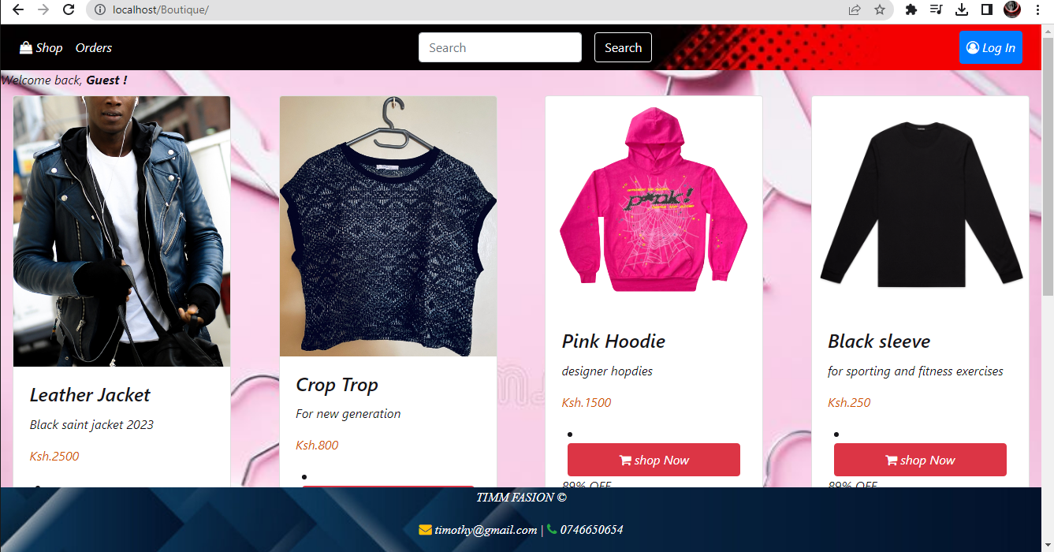

# **CHAPTER FIVE: USER MANUAL DOCUMENTATION**

Creation of a user manual for a website that helps customers find resolutions and thus, increases their satisfaction.

Navigation through the system or website, we have;

**Shop** - located at top left of the website, show you the items and product available in the store.

**Search** – shortcut or a fast way to look for whatever item user want without having looking for all product in the system

**orders –** after user chooses his/her item to buy and owns account, can navigate and click his orders to see item yet to be delivered to him

**Sign in/Login –** at the top right there is a sign in button for a user who intend to buy fashion item and after creating an account he/she can login into website and view item available

**Forgot/Reset password** – if the user can’t remember his password clicks on this option to reset password

These are tools for development used to build the system.

Our website is based on the following tools and programming languages.

MySQL database

Microsoft Word (for documentation)

Visual Studio Code & .NET frameworks

JavaScript, CSS

HTML

PHP

Bootstrap

**Deployment**

Google Chromeany version (Browser)

Firefox.

# **CHAPTER SIX: CONCLUSION AND RECOMMENDATION**

**6.1 Conclusion**

The server processes the customer and clothes are delivered to the address submitted by them. The website is designed into two basic modules, first is for customers who wish to buy the clothes, second is for the admin of the shop who maintains and updates the information concerning to the clothes and those of the customers. The end user of this product is an admin, where the application is maintained and monitors queries of the customers. The website which is deployed. The details of the clothes are brought forward from the database for the customer view based on the selection through the view pages and database of all the clothes are updated at the end.

**6.2 Recommendation**

It copies systems that already exist which have improved our technology, productivity and also able to solve large scale social problems like a system connects us all from all ends of the world. 24/7 accessenables customers to shop or conduct other transactions 24hours a day, all year round from almost any location. For example – checking balances, making payments and other information. Even it has its negative side I recommend the system useful.

I recommend this system. The Boutique Management system is developed to handle your Boutique is really user-friendly website. You easily manage and monitor also see the customer trends in terms of satisfactory and preferences. The users can sign up and login, reset password and after that they are able to order what they want of their choice and products is delivered to them

# **APPENDICES**

|  |  |  |  |  |  |  |  |  |  |  |  |  |
| --- | --- | --- | --- | --- | --- | --- | --- | --- | --- | --- | --- | --- |
|  | **Weeks** | | | | | | | | | | | |
| **Activities** | **1** | **2** | **3** | **4** | **5** | **6** | **7** | **8** | **9** | **10** | **11** | **12** |
| Design |  |  |  |  |  |  |  |  |  |  |  |  |
| Back end - Header/Footer |  |  |  |  |  |  |  |  |  |  |  |  |
| Back end - Home |  |  |  |  |  |  |  |  |  |  |  |  |
| Back end – Login |  |  |  |  |  |  |  |  |  |  |  |  |
| Back end - Products |  |  |  |  |  |  |  |  |  |  |  |  |
| Back-end - cart |  |  |  |  |  |  |  |  |  |  |  |  |
| User interface design |  |  |  |  |  |  |  |  |  |  |  |  |
| Creating the DB – tables & Relationship |  |  |  |  |  |  |  |  |  |  |  |  |

# **REFFERENCE**

Rex Black, 2nd Edition, text documentation from, (Advanced Software testing)

http//.document360.com/index.html/how to create technical documentation/en/.

Johnson Chadwick Hugh, 2015, high level design from, Distributed Network Traffic Controller 1.0

Sherry.Y. Chen, Robert .D. Macredie, the assessment of usability of e-shopping from, International Journal of Information Management.

The Alibaba phenomenon, The Economic march 2013, how does shopping cart work-product database, Retrieved feb 2023.

http//.tutorialspoint.com/what fashion system improved in the society/ Role of fashion in our society/en/index.html

https//.researchgate.net/fashion trends and their impact/index.html

Ingo Schomoger, Steven Broschart, 2018 Silverstripe, The Complete Guide to CMS Development.

Zheng Oin, 2012, web technology from Introduction to E-commerce.

Olayinka Gold, 2018, Custom Clothing Web Application